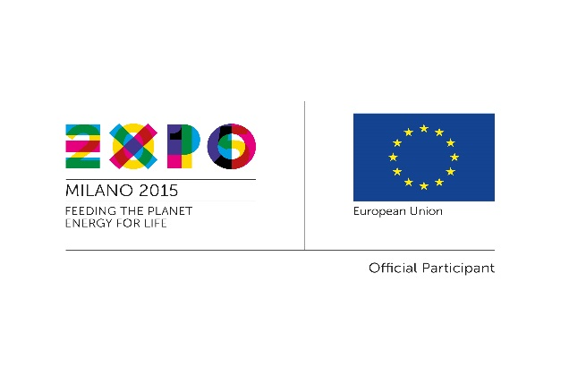
SMEs INTERNATIONALIZATION EVENTS AT EXPO MILANO 2015
www.euexpo2015.talkb2b.net

THE EVENTS
- EU - Mediterranean Countries & Turkey Days (6-7 May, 2015)
- EU - China Days (9-10 June, 2015)
- EU - Latin America and Caribbean (CELAC) Days (12-13 June, 2015)
- EU – Japan Days (10-11 July, 2015)
- EU-Sub Saharan Africa Days (18-19 September, 2015)
- EU - South East Asia (ASEAN) Days (29-30 September, 2015)
- EU - US & Canada Days (5-6 October, 2015 - tbc)

From 1st May 2015 to 31st October 2015, Milan will host the Universal Exhibition EXPO 2015, whose central theme is “Feeding the Planet, Energy for Life” which will be one of the most awaited global events of the year, with the presence of 145 Countries and the expected participation of 20 million visitors.
The European Commission – the Directorate General for Internal Market, Industry, Entrepreneurship and SMES seizes this important occasion to organise a series of high-level events in Milan where EU companies will have the opportunity to meet and discuss about their business with companies coming from targeted Third Countries and Regions.

Generally, the events will last for one day and a half and will be divided into two main moments:
- A conference, during which the framework for the industrial and regulatory cooperation between the EU and the respective Countries will be presented, along with the existing tools to support company access to markets (half day);
- B2B meetings among companies, clusters, research centres, industry-related organizations from the EU and the concerned Third Countries.

The B2B meetings are open to companies from all the participating Countries at EXPO 2015, with a special focus on the respective Countries or Regions mentioned in each event.
SECTORS OF INTEREST
Each event will be focused on specific topics related to the main theme of EXPO 2015:
Agro-food sector: food production, machinery, food conservation, shelf life, packaging, food design, food chain management, logistics and retail, geographical indications, traditional specialties, innovative agro-food industry and craft
Technologies and Services for the agriculture and agro-food industry: safety and quality control, food traceability, space application to agriculture
Biotechnologies and Health
Sustainability: water management, environmental management, renewable energies, sustainable tourism
WHY PARTICIPATE?
• The business-to-business (B2B) meetings are free of charge;
• You will have the opportunity to meet many counterparts from the EU and other Countries, as each event will gather at least 100 companies;
• You will benefit from thorough support before meetings so as to make the most of these opportunities;
• You will learn about the tools the European Commission is putting in place to ease the access to foreign markets and to support business relations between Europe and the concerned Third Countries;
• You will have the opportunity to visit the EXPO Milan further to the participation in such meetings.

CONTACTS
For information please send an email to expoeuevents@mi.camcom.it and visit the website www.euexpo2015.talkb2b.net

THE ORGANIZERS
In organising these events the European Commission is assisted by a European Consortium in charge of organizing the events focused on China - Japan - Sub Saharan Africa, led by Promos-Milan Chamber of Commerce and composed by EUROCHAMBRES and the Chambers of Commerce of Spain, Poland, Paris, Rhône-Alpes, East Flanders and Innovhub.
Furthermore, the European Enterprise Network (EEN) will organize the events focused on Med & Turkey- CELAC - ASEAN- USA & Canada.

