2015 EUROPEAN BEE AWARD
APPLICATION FORM

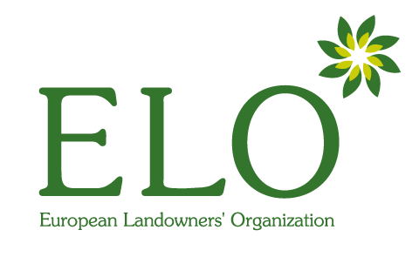
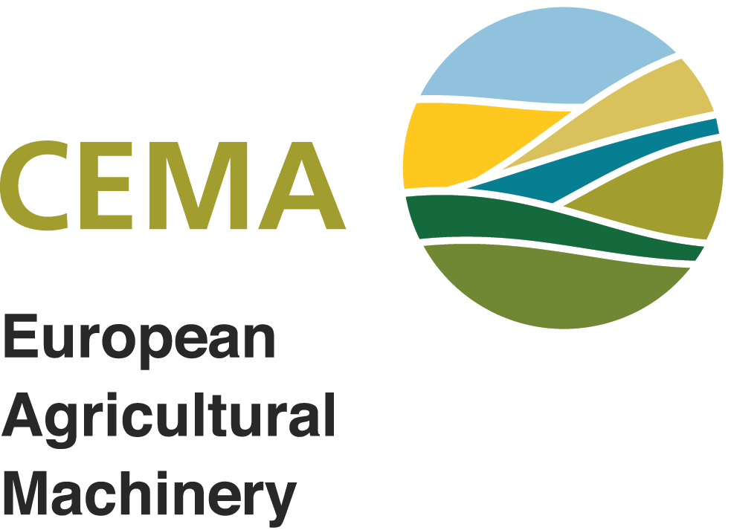

NAME OF THE APPLICATION | click here to enter text
DATE OF SUBMISSION | click here to enter text

In order to be eligible for the European Bee Award, please fill in the three sections of this Application form:

SECTION I. Contact Information
SECTION II. Description of the project
SECTION III. Compulsory Annex
SECTION IV. Optional Annexes

* Winners are expected to take part in the Award Ceremony in Brussels
* Last year non-successful applicants are welcome to apply again
Send this form + annexes by July 15th to one of the following:
By email:
ana.canomanuel@elo.org
(Subject: Bee Award Application)

or By post:
Bee Award application – ELO
Rue de Trèves 67
B – 1040 Brussels

FOREWORD BY THE PRESIDENT OF THE JURY

There is much current concern about the fate of bees and other pollinating insects in European farmed landscapes. With sponsorship from CEMA, the European Landowners’ Organization announces the “European Bee Award”, a prize for a new intervention that promotes the protection of pollinators in the farm environment.

The prize will be awarded to a land manager who possibly together with a partner organisation has developed and implemented a novel practice that helps to reduce the impact of farming operations on honeybees and other pollinators. The type of interventions that might be considered include managing part of the farm in ways that benefit pollinators, improving the availability of flowers and other resources that pollinators require and changes to agronomic practices or the use of farm machinery that are pollinator friendly. The independent jury will take a broad view of possible interventions and welcomes novel and innovative ideas. It will consider practices that benefit not only managed honeybee populations but also wild bees and other pollinators. Interventions that measurably improve pollinator wellbeing on all farm types will be considered (for example farms producing any type of food, and both organic and conventional farming systems).
In choosing the winners of the prize, the jury will take into account how much difference the intervention will make, how novel it is, and its scalability – the likelihood that it will be accepted by farmers and implemented at scale widely in Europe. The jury will look for evidence of the efficacy of the intervention, and will give extra weight to ideas that also benefit non-pollinator biodiversity or that improve the services that pollinators provide for agriculture.

Professor Charles GODFRAY
President of the Jury

ABOUT THE EUROPEAN BEE AWARD

The European Bee Award was launched in 2014 by the European Landowners’ Organization (www.elo.org) and the European Agricultural Machinery Association (www.cema-agri.org) with the aim of contributing to the promotion of common solutions for the benefit of biodiversity.
The European Bee Award will reward farmers, landowners, land managers or rural entrepreneurs who contribute with an outstanding and innovative project to the protection of bees and other pollinators in the farmed environment. Two prizes will be awarded: the winning project will receive a prize of 5,000€ and the second highest ranked project will receive a prize of 2,500€ together with a diploma of recognition and promotion through ELO and CEMA communication channels.
An independent jury chaired by Professor Godfray (University of Oxford) and supported by international experts, members of the European Institutions and NGOs will be in charge of assessing which practices and innovative ideas in agriculture can contribute to preserve the health of pollinators in Europe (e.g. honey bees, bumble bees, flies, butterflies).

EXAMPLES THAT MATCH THE AWARD CRITERIA

- New crop management practices that benefit both managed honeybee populations and also wild bees and other pollinators
- Novel practices that reduce the impact of farming operations on honeybees and other pollinators
- Innovation in integrated pest management that helps pollinators
- New ways to manage non-cropped areas that increase the availability of flowers and other resources for pollinators

THE JURY WILL WELCOME

- Novel and innovative ideas
- Projects that are scalable
- Interventions that can demonstrate efficacy
- Ideas that also benefit non-pollinator biodiversity

SECTION I. CONTACT INFORMATION

Applicant
Short Name | click here to enter text
Legal Name | click here to enter text
Legal Status | Public Private Natural person

Legal Address of the Applicant
Street | click here to enter text | Number | click here to enter text
Postcode | click here to enter text
Town / City | click here to enter text
Country | click here to enter text

Contact Details
Phone | click here to enter text | Fax | click here to enter text
Email | click here to enter text

Contact Person (Only if different from the above)
Title | click here to enter text | Function | click here to enter text
Surname | click here to enter text | Name | click here to enter text
Department | click here to enter text
Street | click here to enter text | Number
Postcode | click here to enter text
Town / City | click here to enter text
Country | click here to enter text

About the participant property
Name | click here to enter text
Address | click here to enter text
Town / City | click here to enter text
Country | click here to enter text
Phone | click here to enter text | Fax
Email | click here to enter text
Website | click here to enter text

Characteristics of the property
Number of hectares | insert number | Owned | insert number | Rented | insert number
Main crops produced | click here to enter text

Partner’s Information
Fill in this section if your project is in partnership. (Please, duplicate for more than one partner)

PARTNER 1
Name | click here to enter text
Street | click here to enter text | Number | click here to enter text
Postcode | click here to enter text
Legal Status | Public Private Natural person

Legal address of the partner
Street | click here to enter text | Number | click here to enter text
Postcode | click here to enter text
Town / City | click here to enter text
Country | click here to enter text

Contact details of the partner
Contact Person | click here to enter text
Phone | click here to enter text | Fax | click here to enter text
Email | click here to enter text

Contact person information (Only if different from the above)
Title | click here to enter text | Function | click here to enter text
Surname | click here to enter text | Name | click here to enter text
Department | click here to enter text
Street | click here to enter text | Number | insert number
Postcode | click here to enter text
Town / City | click here to enter text
Country | click here to enter text

SECTION II. DESCRIPTION OF THE PROJECT

click here to enter text
SUMMARY OF THE PROJECT (150 words max.)

click here to enter text
OBJECTIVES (500 words max.)
METHODOLOGY (500 words max.)
click here to enter text

RESULTS (1000 words max.)
click here to enter text

OTHER INFORMATION FOR THE JURY (1000 words max.)
click here to enter text

SECTION III. COMPULSORY ANNEX

In order to be eligible, please attach a short video or presentation showcasing your project. It will be used for communication and promotion of the winning projects and during the Award Ceremony.

Type of document attached | Description of the document
Short video | clik here to enter text
Power Point | clik here to enter text

SECTION IV. OPTIONAL ANNEXES

The Jury will base its decision largely on the material in Section II tough applicants may submit other material that the Jury may have the option of considering.

Type of document attached | Description of the document
Map | clik here to enter text
Pictures | clik here to enter text
Logo | clik here to enter text
Leaflet | clik here to enter text
Brochure | clik here to enter text
Book | clik here to enter text
Others | clik here to enter text

ACKNOWLEDGEMENT OF RECEIPT

Contact person | click here to enter text
Contact email | click here to enter text
Dear participant,

We thank you for your application and we will acknowledge receipt through your contact email.
The members of the jury will now examine your proposal, and we will announce you the results at the end of the evaluation procedure.

We wish you the best of luck.

Yours sincerely,

European Bee Award Coordination

