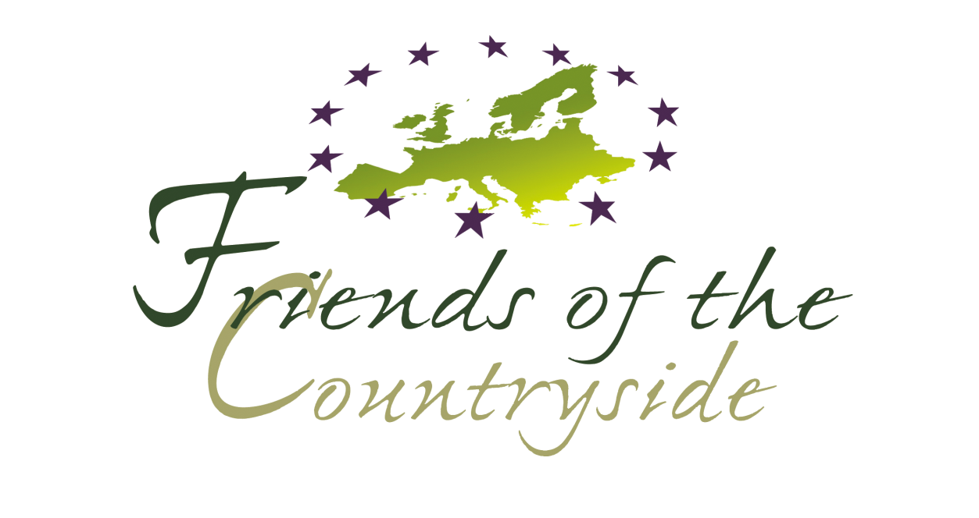

Anders Wall Award

Name of the project

Date

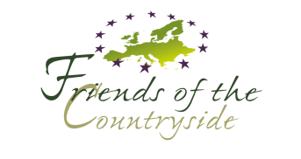

Foreword
Anders Wall Foundation from Stockholm in association with the European Commission, Directorate General for the Environment, Brussels, the Royal Swedish Academy of Agriculture and Forestry and the "Friends of the Countryside", has decided to introduce an award for individuals who have made a special contribution to the rural environment within the European Union.
Description of the Award
Subject:
Anders Wall Award grants a prize to private individuals who have made a special contribution to the rural environment within the European Union.
Eligibility criteria:
- Only private enterprises can enter the competition.
- Their actions must be of importance at multiple levels: local, national and/or European.
- The actions must be based on the use of quality instruments and management practices which contribute to the improvement of the quality of the environment.
Selection criteria:
Their achievements should preferably include the following elements:
- Preserving and enhancing the landscape.
- Providing biodiversity.
- Preserving the countryside's cultural heritage.
- Contributing to sustainable economic local development.
Prize description:
The landowner of the selected project will receive a prize of €15,000.
Deadline:
The call for proposals is open until 31st of December, 2016.
We prefer applications both electronically and on paper, but we also accept forms only filled in by hand.
The application must be sent to the following address (if possible both by post and e-mail):
Anders Wall Award
Friends of the Countryside
Rue de Trèves 67
B-1040 Brussels
Tel: + 32 (0)2 234 2000
Fax: + 32 (0) 2 234 3009
AND
via e-mail to the Award Coordinator at julianna.nagy@elo.org

SECTION A
Administrative Information

Applicant
Short name

Legal Information on the Applicant
Legal Name |  | Legal Status
 |  | ☐Public
 |  | ☐Private
 |  | ☐Natural Person
Street Name and No. |  | P.O.Box
Post Code |  | Town/City
Country Code |  | Country Name

Legal Address of the Applicant
Street Name and No. |  |  | P.O. Box
Post Code |  | Town/City
Country Code |  | Country Name

Applicant Contact Person Information (only if different from above)
Title |  | Function
Surname |  | First Name
Department
Street Name and No |  |  | P.O. Box
Post Code |  | Town/City
Country |  | Fax No
Telephone No |  | Website
E-mail

Location of the project area (only if different from above)
Name
Address
Town/City |  | Post Code
Country
Telephone No. |  | Fax No
E-mail |  | Website

Characteristics of the Applicant
*This section MUST be filled in
Number of hectares (owned/rented/total)
Number of Employees Developed Over the Years/Today
Annual Turnover of the Activity
Latest economic result

Map of location (simple google map is sufficient):

The contents of this application form and any attachments are confidential and are intended solely for the Secretariat and Jury of the Anders Wall Award, no information will be circulated or transferred to third parties.
Partner 1

Legal Information on the Applicant’s Partner (if any)
Legal Name |  | Legal Status
 |  | ☐Public
 |  | ☐Private
 |  | ☐Natural Person
Street Name and No. |  | P.O.Box
Post Code |  | Town/City
Country Code |  | Country Name

Contact Person Information (only if different from above)
Title |  | Function
Surname |  | First Name
Department
Street Name and No |  |  | P.O. Box
Post Code |  | Town/City
Country
Telephone No |  | Fax No
E-mail |  | Website

Partner 2

Legal Information on the Applicant’s Partner (if any)
Legal Name |  | Legal Status
 |  | ☐Public
 |  | ☐Private
 |  | ☐Natural Person
Street Name and No. |  | P.O.Box
Post Code |  | Town/City
Country Code |  | Country Name

Contact Person Information (only if different from above)
Title |  | Function
Surname |  | First Name
Department
Street Name and No |  |  | P.O. Box
Post Code |  | Town/City
Country
Telephone No |  | Fax No
E-mail |  | Website

SECTION B
Executive Summary of the Project
Project outlines
Project Timeframe

Project Area (including history, features in max 500 characters)

Project vision, objectives, and goals
General vision of the project (max 500 characters)

Main principles on which the project focuses (max 500 characters)

Short term objectives (max. 250 characters)

Long term objectives (max. 250 characters)

Additional elements/targets (if any) (max. 250 characters)

Methods
Actions and Means Involved - highlighting the use of quality instruments and management practices which contribute to the improvement of the quality of the environment and their importance at multiple level: local, national and/or European. (max. 1800 characters)

Results
Measurable results in the context of sustainable development
(max. 3600 characters)

Other results (if any) (max. 500 characters)

General Description of the Project
Project Description (max. 18.000 characters)

SECTION C
Annexes

Topographic Documentation
Map | ☐Showing location of the estate in the national context of the estate
 | ☐Localization of the actions in the estate (land use, development…)
 | ☐Other

Other documentation
Type of Document | ☐Book
 | ☐Leaflet
 | ☐Brochure
 | ☐Picture
 | ☐Map
 | ☐Other

Acknowledgement of Receipt

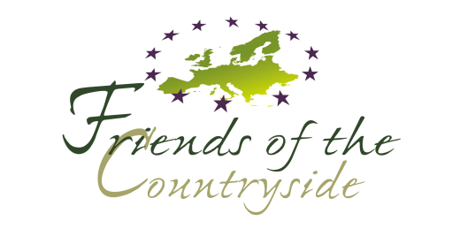 | Friends of the Countryside  Rue de Trèves, 67  B – 1040 Brussels

Name of Applicant*

Contact Person*

Fax*

Title of the Project*

*to be filled out by the applicant

Sir / Madam,

I acknowledge receipt of your proposal for which I thank you.
Your proposal will be examined by the members of the Jury, with respect to its eligibility. Those projects declared eligible will then undergo an evaluation procedure by the Jury.
I will let you know the final decision, as soon as it has been taken.

Yours faithfully,

Signature:

